**LAB 1**

Q2: Find the average of three numbers input by a user.

**Algorithm –**

1. Start
2. Take three numbers a,b,c as input and store them in respective variables.
3. Make two variables named as “Sum” and “Average”
4. Sum = a + b + c
5. Average = Sum / 3
6. Print the value of Average
7. End

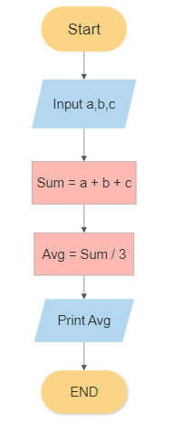

**SPARSH CHADHA**

**E18CSE179**